Independent Course work I – WS 2019/2020

Master Software Engineering for Industrial Applications

University of Applied Science Hof

NutriSpec Project

Project Guide: Mr. Oliver Hader

Participants

|  |  |
| --- | --- |
| Kunal Harkare | 00512519 |
| Nikhil Gosavi | 00608419 |
| Sudarshan Phule | 00510519 |
| Sachin Tiptur | 00518719 |
| Akhil Baby | 00571419 |

Table of Contents

Planning 3

Concept 3

Structure & Navigation 3

Layout and Wireframes 4

Use Cases 8

Domain Model/ER Diagram/Class diagram 9

Activity Diagrams 10

Activity diagrams of enrol and disenroll client 11

Project Organization 12

Implementation 12

Quality Assurance 13

Automated Test Cases 13

Conclusion 13

Pros 13

Cons 13

# Planning

## Concept

Our application ‘NutriSpec’ aimed at every individual to search, consult nutritionist and maintain their Nutrition plan. This also connects client with Nutritionists based on the location of the client, Nutritionists to manage their clients’ data and consult online. It enables nutritionists to provide their service online by interacting with clients over this application.

Nutritionists can enrol with the ‘NutriSpec’ company administrator and make their profile visible/reachable to millions of clients. They can also get a personalized Nutritionist page with details of their clients and related data. Nutritionist can update the client information with the consultation reports and diet prescriptions. Also, he can monitor the progress of the client. A nutritionist can also write blogs and success stories in the application.

Client can search for a Nutritionist without requiring a registration. A location-based search is possible with ‘NutriSpec.’ Client can get contact details of the Nutritionist and view the Nutritionist profile, ratings, qualifications, blogs and success stories. Client can also contact Nutritionist via ‘NutriSpec’ online contact form.

Registration of each user to help monitor the individual separately and accurately. The record of user's history would be analysed to ensure better diagnosis which would be concentrated to the concerned user. User Personalization would also make users more engaged in the activities which would increase the probability of completing the tasks and thus resulting in maintaining good health. Relevant and tailored experiences also boost user retention.

# Structure & Navigation

|  |  |  |  |
| --- | --- | --- | --- |
| ID | TITLE | SCOPE | URL/PATH |
| 1 | Home Page | Login links to Nutritionist and Client home pages and also shows images in carousel | /overview |
| 2 | Client Home | List all nutritionist, search nutritionist, view blogs | /client-home |
| 2.1 | My reports | Display prescriptions from nutritionist | /client-home/reports |
| 3 | Nutritionist Home | List all enrolled client details, prescribe client, disenroll client, view blogs | /nutritionist-home |
| 4 | About Us | Information about NutriSpec | /about-us |
| 5 | Contact Us | Contact form (name, email, subject, message) | /contact-us |
| 6 | News | Recent News and announcements | /news |
| 6.1 | Vlog | Health and nutritional videos | /news/vlog |
| 7 | Legal Information | Legal information, address information, privacy policy. | /legal-information |

Table 1: Page Structure and content map of NutriSpec Application

# Layout and Wireframes

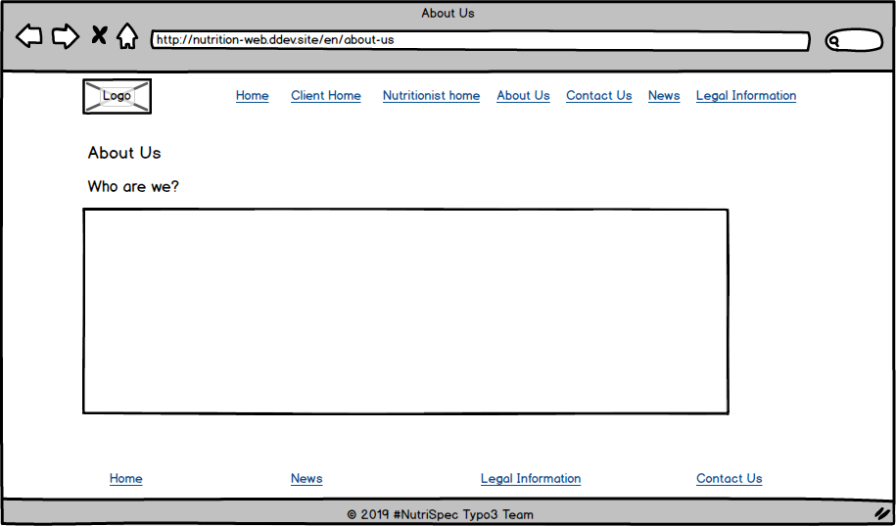

Figure 1. About Us page of NutriSpec

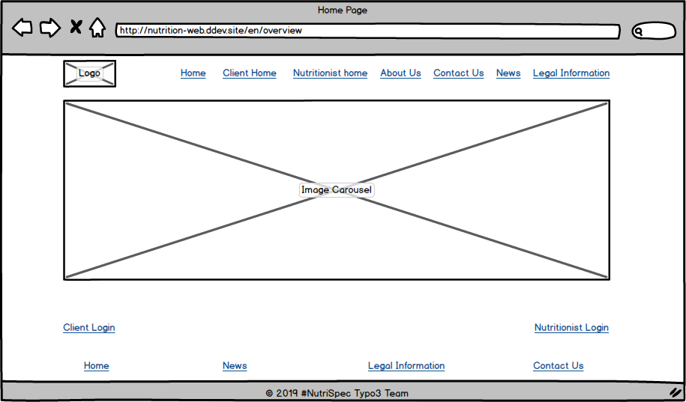

Figure 2. Home page layout showing logo and carousel

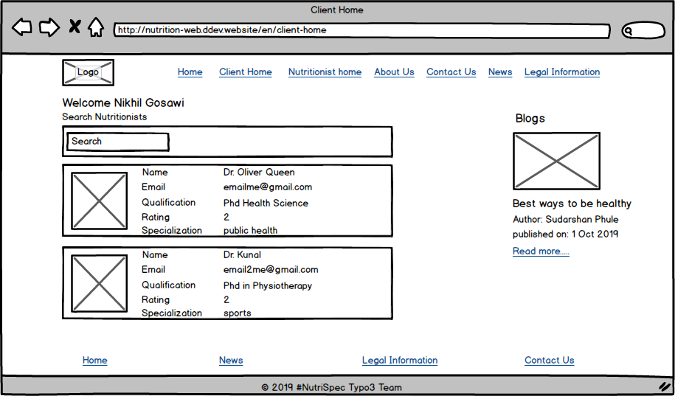

Figure 3. Client page of NutriSpec

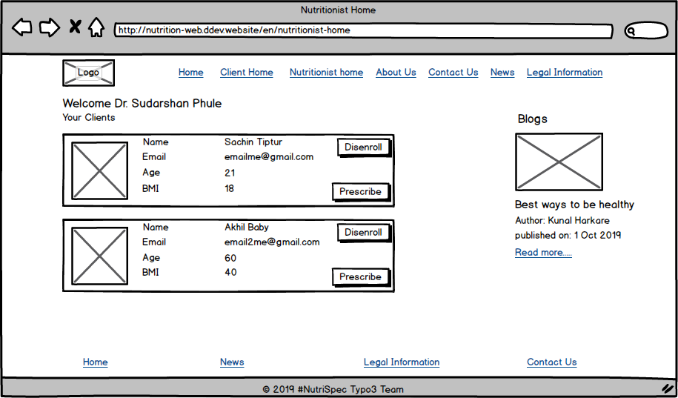

Figure 4. Nutritionist page showing list of clients

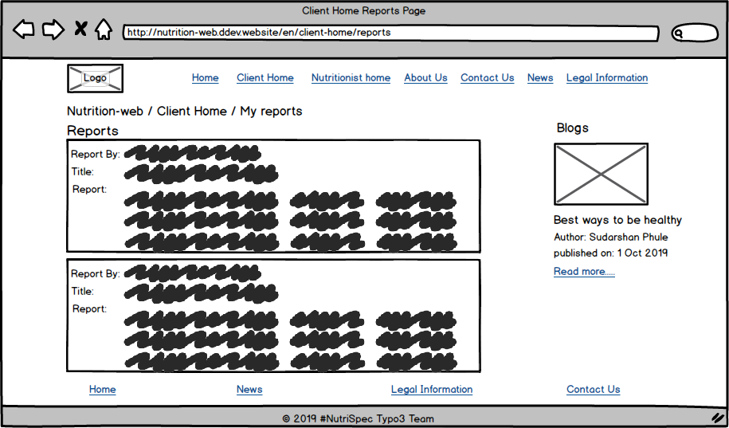

Figure 5. Client’s Report page

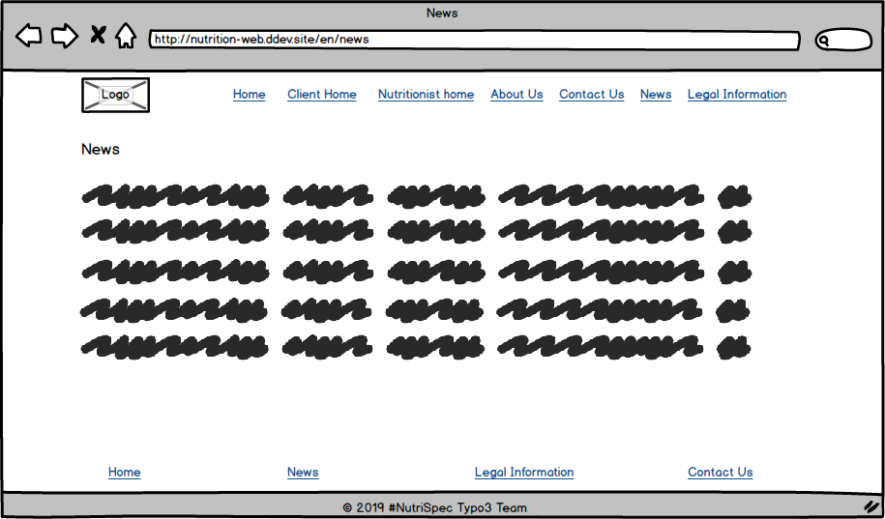

Figure 6. New page

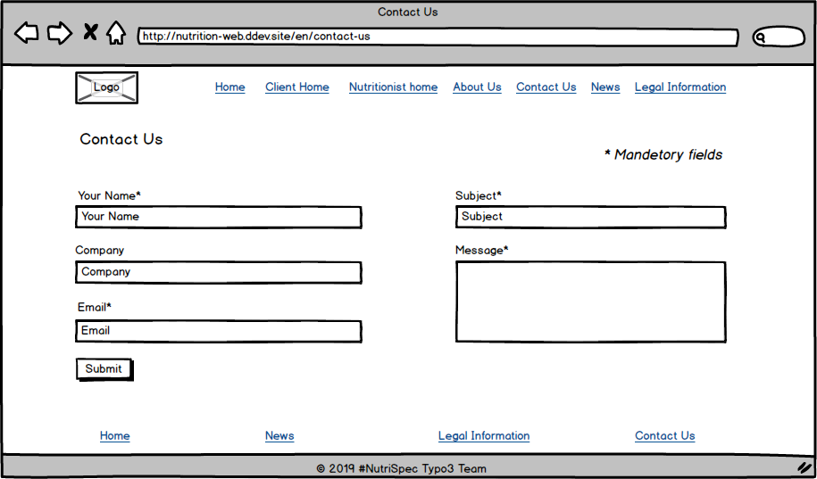

Figure 7. Contact Us page

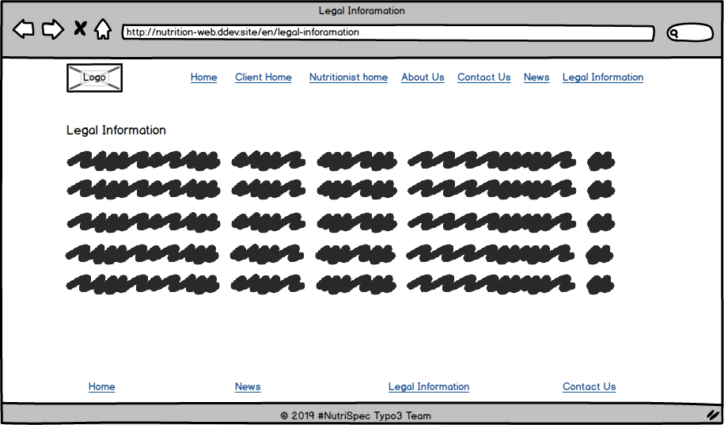

Figure 8. Legal information page

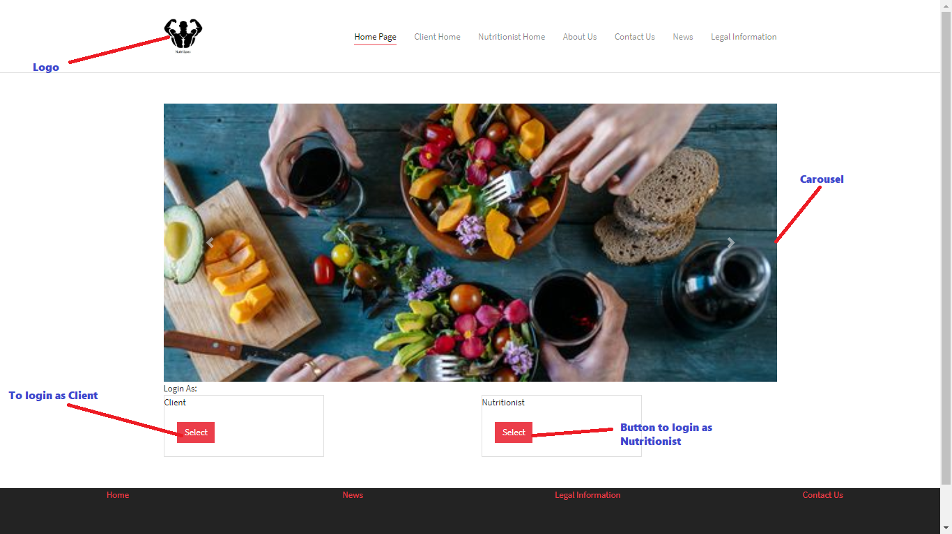

Figure 9. Home Page layout

# Use Cases

There are basically two types of users who can use this application. First one is nutritionist who can list his all clients, view client’s information, prescribe client and can create blogs.

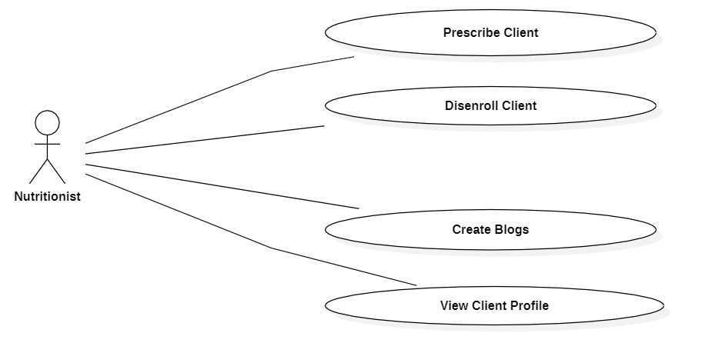

Nutritionist Role Use Case

Second actor is client who can search for nutritionist, view nutritionist profile, enrol with nutritionist, view blogs and give ratings to nutritionist.

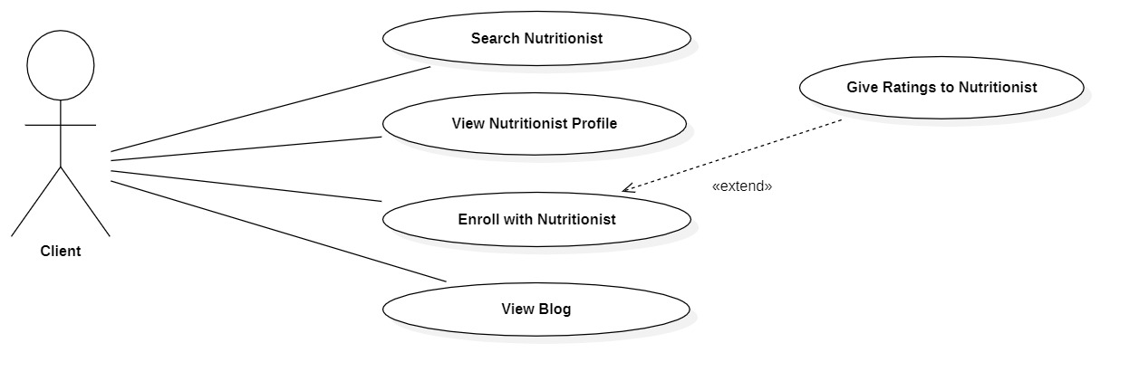

Client Role Use Case

# Domain Model/ER Diagram/Class diagram

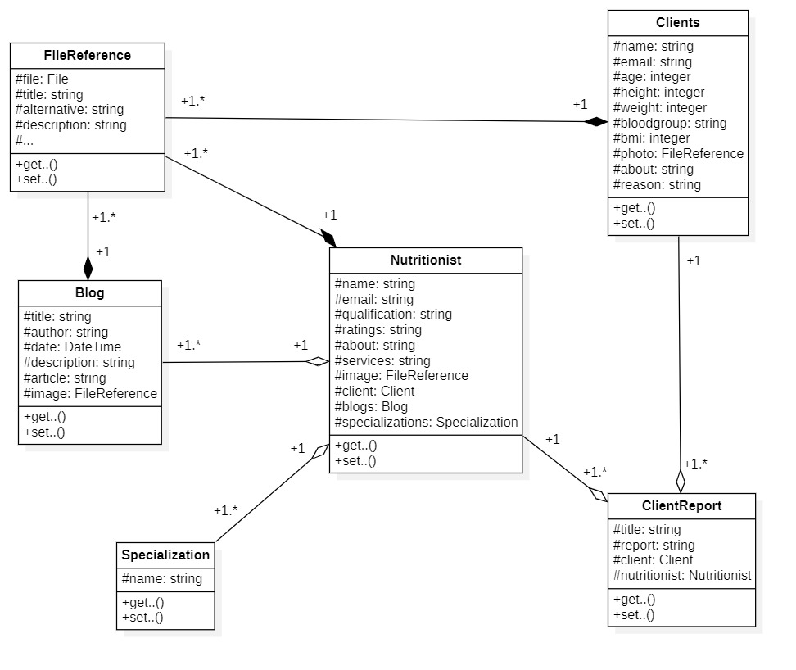

Class Diagram

# Activity Diagrams

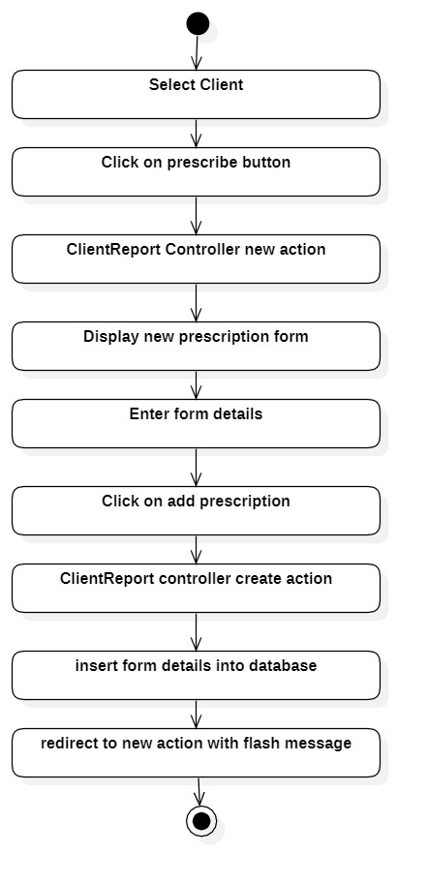

Prescribe client activity diagram

## Activity diagrams of enrol and disenroll client

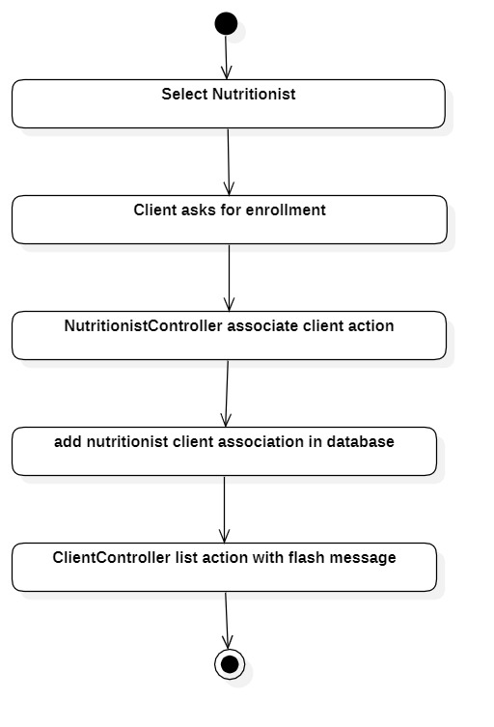

Enrol with nutritionist activity diagram

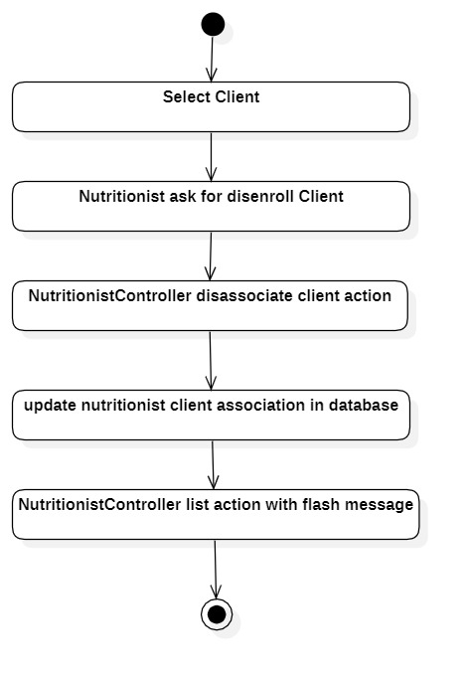

Disenroll with Client activity diagram

# Project Organization

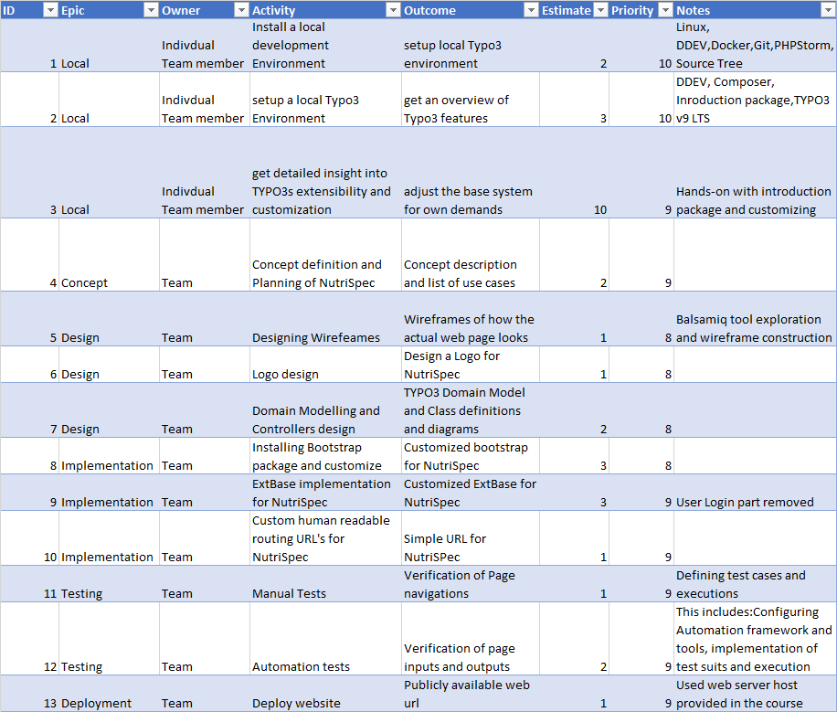

# Implementation

# Quality Assurance

## Automated Test Cases

Webpage inputs and outputs are verified using Automated test cases. Katalon studio based on Selenium is used for implementing and testing NutriSpec test suits. Katalon Studio uses open-source test automation frameworks such as Selenium and Appium by eliminating their technical complexities. This enabled us to set up, create, run and report automated tests.

# Conclusion

Overall experience in learning TYPO3 was good and enhanced our web development skills and CMS knowledge. It exposed us to different tools and environments like Docker, DDEV and Github. With the time and the limited knowledge, we were able to build a NutriSpec web site with all basic functionalities like navigating to difference pages, providing ability to contact and enrol with Nutritionists, to view vlogs and news on the site. But not able to implement some features like location-based search, chatbots and registration etc.

From our little experience, below are few pros and cons of TYPO3:

### Pros

* Long term software support for LTS versions
* Supports multi-lingual websites and managing multi-language content in an easy
* Able to manage very large and complex websites required for big business & major organisations
* Good range of free 3rd party plugins

### Cons

* Complexity is high to set up & maintain (i.e. apply bug fixes, security updates), and to add new features
* Limited 'themes' to change look & design of website without use of professional web developers
* No automatic updates for the CMS